Customized virtual File System

Platform required

Windows NT platform OR Linux Distributions

Architectural requirement

Intel 32 bit processor

User Interface

Command User Interface

SDK used

None

Technology used

System Programming using C

About Virtual File System

* In this project, we emulate all data structures which are used by operating system to manage file system oriented tasks.
* As the name suggest, its virtual because we maintain all records in primary storage.
* In this project we create all data structures which required for File Subsystems as Inode Inode Table, File Table, UAREA, User File Descriptor Table, Super block, Disk Inode List Block, Data Block, Boot Block etc.
* We provide all implementations of necessary system calls and commands of File subsystem as Open, Close, Read, Write, Lseek, Create, RM, LS, Stat, Fstat etc.
* While providing implementations of all the above functionalities, we use our own data structures by referring Algorithms of UNNIX operating system.
* By using this project, we can get overview of UFS(UNIX File System) on any platform.

Data Structure used in the project

Single Linear Linked List

Diagram of Data Structures used in the project

Flow of the project

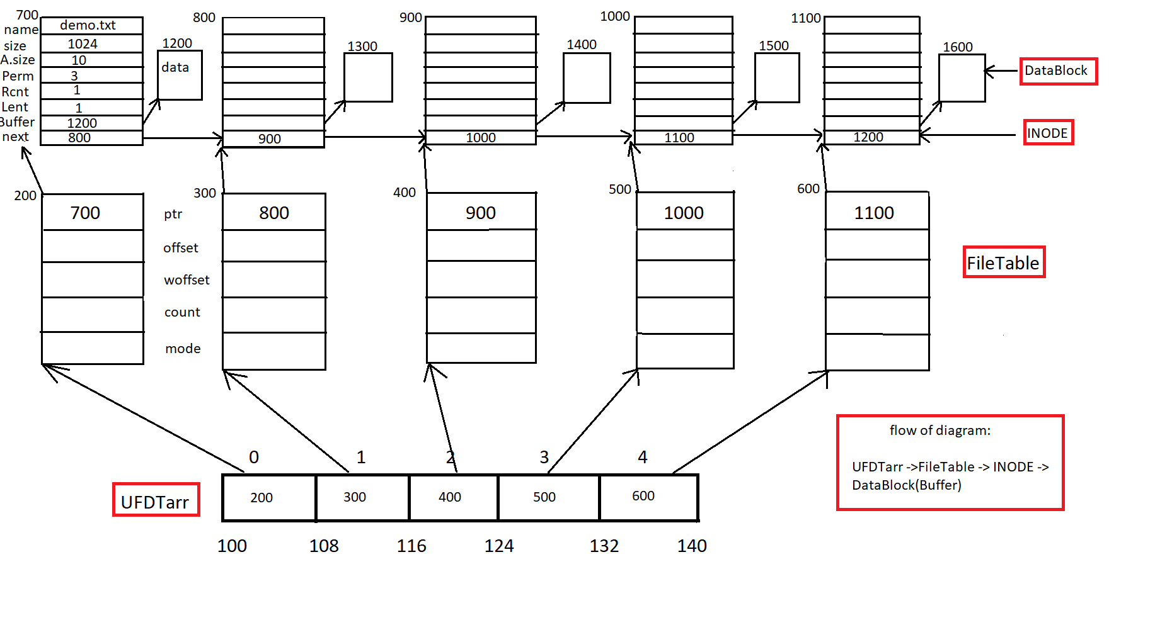

Code of the project (separate file on github)

Screenshots of the project

